Understanding Information Needs and Behaviour in Brain Tumour Patients: A Qualitative Study Across Pre- and Postoperative Phases

Abstract
Background: When individuals receive a health diagnosis, they often find their existing knowledge inadequate to understand condition or decide on the next steps, creating various information needs. Well-informed patients can make decisions based on reliable information.
Objectives: This study aims to understand the information needs, sources used and information-seeking behaviour of brain tumour patients and identify the motivators that prompt their information-seeking.
Methods: Semi-structured interviews were conducted with 29 patients diagnosed with a brain tumour who underwent or were awaiting surgery at the University Hospital of Osijek, Croatia.
Results: Patients have various information needs. They place high trust in doctors as a source of information. Some patients feel they do not receive enough clear and understandable information. Uncertainty and lack of information are motivators that result in various forms of information behaviour.
Discussion: There are many different types of information seeking in response to a brain tumour diagnosis and subsequent surgery, from very active to somewhat passive. Sometimes the information provided is hard for patients to understand.
Conclusion: Health information specialists' active involvement and support in shaping and disseminating recent and relevant health information should enable doctors and patients a shared understanding efficiently and effectively.

Keywords: health information needs, information-seeking behaviour, information sources, patients, research, qualitative

Key messages:
For successful consultations before and after major surgery, patients need to be encouraged to ask questions.
Health information specialists should empower patients to actively manage their health by offering resources, such as educational materials, online platforms, and support groups.
Health information specialists need to collaborate with doctors concerning tailoring information for patients.

Background

Brain tumours significantly impact patients globally, with Croatia among European countries having the highest incidence and mortality rates (Salari et al., 2023; HZJZ, 2022). Standard treatments include surgery, often supplemented by radiotherapy or chemotherapy, depending on tumour characteristics (HeMED, 2023). Regardless of malignancy, brain tumours substantially impair quality of life, causing physical and cognitive difficulties requiring medical support. Patients frequently face challenges understanding their diagnosis and treatment, making reliable health information crucial for informed decision-making. Most existing research on health information needs broadly targets cancer patients, neglecting specific tumour distinctions. Investigating whether these patterns apply to brain tumour patients is important due to unique aspects of their diagnosis and treatment. Although health information can reduce anxiety and improve patient outcomes, specific research on information needs of brain tumour patients remains limited globally and in Croatia. To our knowledge, this study is the first in Croatia addressing this research gap. Understanding patients' information needs throughout treatment, particularly in surgical settings, is essential. Surgery, minor or major, is highly stressful for patients, families, and caregivers. Patients need reassurance, clear explanations, and answers to their questions before and after surgery. Shared decision-making preoperatively ensures patients understand their condition, treatment options, and expected outcomes. However, the effectiveness of preoperative information varies with patient characteristics and surgical complexity, highlighting the need for tailored communication (Fleisher, 2023). Preoperative discussions enable patients to ask questions, but anxiety or complex medical terminology often hinders their understanding (Gautschi et al., 2010). Providing consistent, reliable information can reduce anxiety, enhance trust in healthcare providers, and facilitate informed consent. Patients feeling inadequately informed experience greater preoperative anxiety, underscoring the importance of personalized, timely information (Doñate Marín et al., 2015). Postoperative information is equally vital, aiding pain management, recovery challenges, and rehabilitation adherence. Healthcare professionals, especially surgeons, nurses, and trusted sources, significantly reduce stress and set realistic recovery expectations (National Institute for Health and Care Excellence, 2020). Effective preoperative education helps patients comprehend their condition, procedure risks, and recovery expectations (Chieffo et al., 2023). Well-informed patients report lower stress and better adherence to postoperative care (Warren et al., 2014; Alamanou et al., 2016). Patients actively seek preoperative information, primarily online or via healthcare professionals (Abdul-Mushin et al., 2017). However, postoperative information-seeking typically declines, possibly due to perceived adequacy or reduced motivation. Extensive preoperative information-seeking correlates with choosing more complex surgical interventions, illustrating the influence of information availability on decision-making (Abdul-Mushin et al., 2017). Although pre- and postoperative information critically impact outcomes, information needs begin earlier, at diagnosis—the often most overwhelming phase (Chua et al., 2018). Individuals with serious conditions have heightened needs for information to navigate diagnosis, treatment, and prognosis, evolving with disease complexity over time (Schaeffer, 2016). Clear health information is essential for informed consent and patient autonomy (Sorta-Bilajac, 2011). Despite legal frameworks guaranteeing access—such as Croatia’s Patients’ Bill of Rights (Croatian Parliament, 2004), EU Directive on Patients’ Rights (European Parliament and Council, 2011), Oviedo Convention (Council of Europe, 1997), and WHO Declaration on Patients’ Rights (WHO, 1994)—patients still face challenges obtaining accurate, comprehensible medical information (Alamanou et al., 2016; Wittmann et al., 2010). Cancer patients, including those with brain tumours, require extensive information to understand their diagnosis, evaluate treatments, cope, and manage side effects (Chang et al., 2019). Chronic patients increasingly seek practical, day-to-day guidance (Ancker et al., 2015). These patients have specialized information needs related to coping, lifestyle management, and decision-making (Tesfa, 2024; van der Smissen et al., 2021; Zhang et al., 2022). Meeting these needs improves quality of life, treatment adherence, and psychological well-being (Mohamadali et al., 2018), yet significant informational gaps persist, especially in advanced-stage cancer (Chua et al., 2018). Information needs change over time, initially prioritizing diagnosis and treatment options, later shifting toward recovery, rehabilitation, and quality of life (Madge et al., 2023). Despite digital resources, patients mainly rely on healthcare providers, especially surgeons and oncologists, due to limited awareness of alternative sources like health librarians (Madge et al., 2023). Many patients struggle to differentiate reliable from unreliable online information, highlighting the importance of structured guidance by healthcare professionals (Abdul-Mushin et al., 2017). Information-seeking behaviors vary widely, influenced by individual preferences, cancer-related stress, age, and education levels (Looper et al., 2021; Nizet et al., 2023). Some patients actively seek detailed information for control, while others rely passively on healthcare providers. Some deliberately avoid information due to fear or stress—termed information avoidance (Brashers et al., 2002; Miller, 1995). Health information-seeking encompasses direct searching, monitoring, and passive acquisition, influenced by emotional responses and uncertainty management (Zimmerman & Shaw, 2020; Brashers, 2001). Within this framework, seeking and avoidance are understood not as opposing forces but as complementary coping strategies (Brashers et al., 2002; Rains & Tukachinsky, 2015). Avoidance may constitute a deliberate and adaptive response to distressing or overwhelming content, rather than simply the absence of seeking (Hicks et al., 2024). A key form of active engagement is online health information seeking (OHIS), particularly among younger, more educated individuals and those experiencing heightened cancer-related stress or employing a monitoring coping style (Looper et al., 2021). OHIS is linked to improved affective outcomes, such as greater treatment satisfaction and reduced anxiety, as well as enhanced cognitive outcomes like better information recall (Faller et al., 2016; Katavić et al., 2016; Persakis & Kostagiolas, 2020). Information behaviour varies with psychological traits and coping styles. As individuals navigate the healthcare system and their specific condition, they engage with multiple health discourses and develop 'ways of knowing'—that is, understandings of how information is produced, disseminated, and accessed across contexts (Lloyd, 2006). Task complexity, shaped by perceived difficulty and prior knowledge, influences information source selection. As complexity rises, individuals engage in broader, less structured searches, favouring diverse and adaptable resources (Byström, 2002; Saastamoinen et al., 2012). Personality traits also shape perceptions of medical situations and emotional responses; openness correlates with intellectual engagement, whereas neuroticism predicts negative appraisals (Rauthmann et al., 2014; Rauthmann et al., 2015). These perceptions, in turn, affect tendencies toward information seeking or avoidance. Assessing personality traits thus offers valuable insights into patient information behaviour and supports more effective communication strategies (Schönbrodt & Perugini, 2013). According to Miller (1995), individuals adopt either a monitoring style—active information seeking—or a blunting style involving avoidance or distraction, both of which influence engagement with health information (Lambert & Loiselle, 2007; Loiselle, 2019). Avoidance is particularly salient in distressing contexts: 30–40% of cancer patients avoid illness-related information (Carlsson, 2000; Loiselle, 2019; Sweeny et al., 2010), often driven by emotional factors such as fear of cancer (Miles et al., 2008; Nelissen et al., 2015) or prior experience with serious illness (Barbour et al., 2012).Patients' broader approaches to health information can be described along behavioural spectrums. Costello and Veinot (2020) identify five user types: avoiders, receivers, askers, seekers, and verifiers. Lambert et al. (2009a, 2009b) describe five patterns specific to cancer contexts: intense, complementary, fortuitous, minimal, and guarded seeking. These models reflect the diversity and fluidity of information behaviour throughout the illness trajectory (Germeni & Schulz, 2014; Shim et al., 2016). Importantly, seeking and avoidance are not mutually exclusive, but often occur simultaneously. Patients may pursue certain types of information while deliberately avoiding others, depending on emotional readiness, personal beliefs, or perceived relevance (Petersen et al., 2021; Jensen et al., 2021). In digital environments, this is reflected in selective exposure—seeking information that confirms pre-existing views—and selective avoidance, where challenging or distressing content is ignored (Kwanya, 2016; Malinen et al., 2018). Health information specialists (HIS), as defined in the literature, play a crucial role in ensuring that patients have access to accurate, evidence-based health information. Their responsibilities include guiding patients toward trustworthy medical sources, helping them navigate complex health data, and mitigating the risks of misinformation (Seeger, 2015). They are also described as professionals who develop tailored educational programs to enhance patients’ understanding of diagnoses and treatment options, thereby fostering greater autonomy in health-related decision-making (Butler, 2019; Pizzarelli et al., 2019). In addition, HIS professionals are positioned to collaborate with physicians and nurses, providing real-time informational support and alleviating the burden on medical staff, while ensuring that patients receive clear and timely explanations of their medical conditions (Frati, 2014). This is especially relevant for brain tumour patients, who often face cognitive and emotional difficulties in processing complex medical information. Librarians, through proactive involvement in patient education, help bridge communication gaps between healthcare providers and patients, supporting health literacy and informed decision-making. Their expertise is essential in guiding patients through an increasingly complex and overwhelming information landscape. While the information needs of cancer patients have been widely studied, research specifically addressing brain tumour patients—particularly in the preoperative and postoperative phases—remains limited. Given their specific challenges, understanding how these patients seek, access, avoid, and interpret health information is vital. This study addresses these gaps by examining the information behaviours of brain tumour patients in Croatia, focusing on trusted sources, motivational factors, and barriers to comprehension, with the aim of improving education, communication, and the delivery of timely, accurate, and personally relevant information.

Objectives
The aim of this study is to explore the information needs and information-seeking behaviour (ISB) of brain tumour patients in Croatia, focusing on those who are awaiting surgery or have already undergone the procedure. Particular attention is given to the sources patients trust, the motivations behind their behaviour, and the challenges they face in accessing and interpreting health-related information during the preoperative and postoperative phases. In this context, the following questions can ensure a decent level of relevance:
RQ 1: What information needs do patients with brain tumour in the pre- and postoperative period have?
RQ 2: What is the trust level of patients with a brain tumour in the pre- and postoperative in the information sources they use?
RQ 3: What are the motivators that led patients to seek information independently?
RQ 4: What are the forms of information behaviour exhibited by patients before and after the surgery?
Methods
This study employed a descriptive qualitative methodology to delve into patients' experiences and opinions regarding brain tumours and their surgeries. Interviews were conducted as the primary method to gather rich and detailed data. Approval for the research was granted by the Ethics Committee of the University Hospital of Osijek, Croatia as evidenced by decision no. R1-11259/2023, allowing the study to proceed.

Study setting and participants

The interview comprises patients diagnosed with a brain tumour (N=29), who had undergone (N=17) or were awaiting surgery (N=12) at the time when they were queried. There were 15 female and 14 male respondents aged between 28 and 79 years, as shown in Table 1.

Table 1. Information of participants

Ptcpnts code | P1 | P2 | P3 | P4 | P5 | P6 | P7 | P8 | P9 | P10 | P11 | P12 | P13 | P14 | P15 | P16 | P17 | P18 | P19 | P20 | P21 | P22 | P23 | P24 | P25 | P26 | P27 | P28 | P29
Sex | F | F | F | M | F | M | M | M | M | F | M | F | M | M | F | F | F | F | M | M | F | F | F | F | M | M | M | F | M
Age | 70 | 63 | 57 | 65 | 28 | 60 | 79 | 37 | 76 | 43 | 68 | 42 | 68 | 28 | 34 | 46 | 53 | 63 | 30 | 37 | 36 | 50 | 53 | 61 | 57 | 44 | 50 | 51 | 30
Pre-srg. |  | X | X | X |  | X | X | X | X | X | X |  |  | X |  |  |  | X |  |  |  |  |  |  | X
Postsrg. | X |  |  |  | X |  |  |  |  |  |  | X | X |  | X | X | X |  | X | X | X | X | X | X |  | X | X | X | X

Data Collection

This study employs a semi-structured interview format, which was recorded and subsequently transcribed for analysis. Patients who had already undergone surgery were contacted by phone as part of their postoperative follow-up and invited to participate, while those awaiting surgery were approached in the hospital, provided informed consent, and interviewed prior to the procedure. The interview guide (see Appendix) was designed to accommodate both groups—those recovering from surgery and those in the acute preoperative phase—acknowledging their differing experiences and levels of prior engagement with health information. The questions were developed based on existing theoretical literature and empirical research on the information needs and behaviours of patients with chronic and life-threatening illnesses. This approach ensured that the instrument captured the emotional, cognitive, and practical dimensions of the patient experience, grounded in current evidence and conceptual frameworks.
The research was conducted during the last quarter of 2023 at the Department of Neurosurgery and the Department of Neurology at the University Hospital Osijek, Croatia.

Interview procedure

The interviews were conducted in Croatian and took place in the hospital, in a separate room provided by doctors or medical staff. Four patients who had moved from Osijek or lived far away were interviewed via the Zoom platform. At the respondents’ request, two interviews were conducted at the Faculty of Humanities and Social Sciences in Osijek.
Not all questions were asked in every interview: certain questions were skipped when not applicable, particularly in cases where patients did not engage in active information seeking. In some preoperative patients, increased anxiety may have resulted in shorter responses, although the relevant questions were still asked. Interviews lasted approximately 20 minutes. All interviews were audio-recorded and then transcribed verbatim.

Data analysis

Each participant was assigned a code based on the order of interview (P = participant and ordinal number). The interviews were subjected to qualitative content analysis using a thematic analysis approach. The answers were translated into English. MAXQDA software was employed to analyze and interpret the obtained data. To support interpretation, selected qualitative findings were also visualized in the form of thematic diagrams. These diagrams were developed using the final coding framework to illustrate relationships among core themes and subthemes. The visual representations were created using Miro, an online collaborative whiteboard platform that enabled the organization and mapping of qualitative categories in a structured and accessible format.

FINDINGS
Health information needs
There are four main categories of information needs expressed by brain tumour patients in this study. These needs were grouped into four overarching themes: understanding the disease, surgical concerns, post-surgical recovery, and doctor’s competence. Participants expressed a desire for detailed information on tumour types, causes, and treatment options, as well as long-term outcomes. Many were particularly concerned with the success of surgery, postoperative limitations, and recovery processes. A significant aspect of these needs was the level of trust patients placed in various information sources. As shown in Figure 1, patients’ trust shaped their preferred sources of health information—ranging from doctors to personal contacts and online platforms. Representative quotations from participants (identified by codes such as P1, P4, P11) are included to contextualize each category.
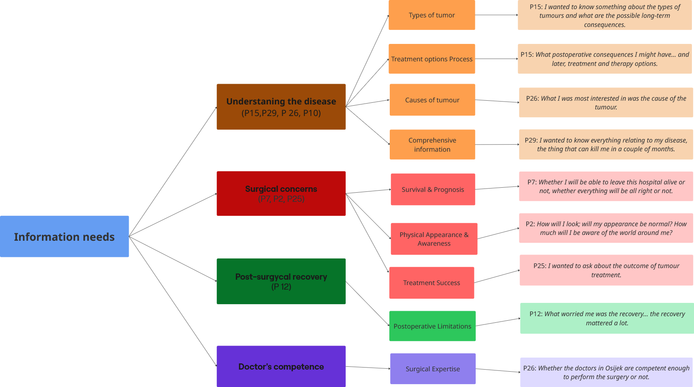
Figure 1. Health information needs among brain tumour patients.
Legend: colour-coded branches indicate subthemes such as understanding the disease (orange), surgical concerns (red), post-surgical recovery (green), and perceptions of doctor’s competence (purple). Patient quotes (identified by participant ID, e.g., P1, P7 etc.) illustrate each subcategory.
Trust in information resources among brain tumour patients

Participants in this study demonstrated varying levels of trust in the health information sources they used. As shown in Figure 2, three distinct levels of trust were identified: high, moderate, and low. These trust levels were closely linked to the types of resources patients relied on—primarily doctors, other personal resources (such as family members or friends in healthcare), and the internet. Patients who expressed high trust overwhelmingly relied on doctors, often describing them in highly positive and authoritative terms. Those with moderate trust tended to use a combination of sources, including nurses, acquaintances with medical knowledge, and independent online searches. In contrast, participants with low trust were generally skeptical about online information, voicing concerns about its reliability and the difficulty of navigating conflicting content. Representative quotes (e.g., P4, P11, P1) illustrate how patients assessed and selected their information sources.
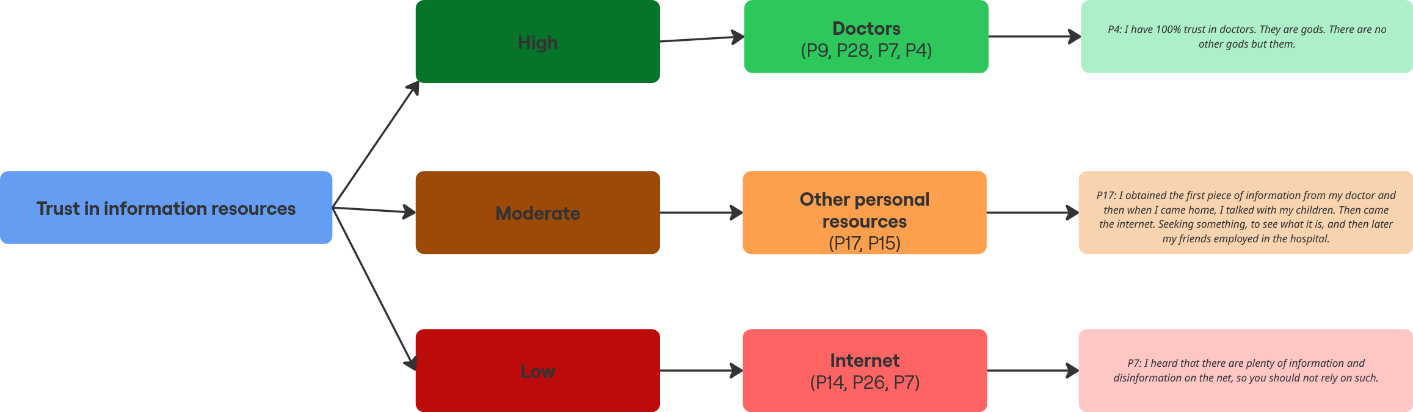

Figure 2. Levels of trust in information resources among brain tumour patients
Legend: Colour-coded branches indicate trust levels—green for high, brown for moderate, and red for low—each connected to a preferred information source and illustrated with a representative patient quote.
3. Motivators for information seeking among brain tumour patients
In addition to identifying what kinds of health information patients needed, this study also explored why they sought out that information. As shown in Figure 3, four key motivators emerged from the data: lack of information, insufficient information, untimely delivery of information, and a desire for better understanding of the disease. Participants often felt that the information provided by healthcare professionals was delayed, incomplete, or entirely missing. These gaps in communication prompted them to search for answers independently. In several cases, patients were motivated by new or unexplained symptoms, or by a general need to better understand treatment options, medication effects, and their overall condition. Quotes from participants (e.g., P2, P15, P28) help contextualize each motivator and illustrate how these experiences shaped their information-seeking behavior.

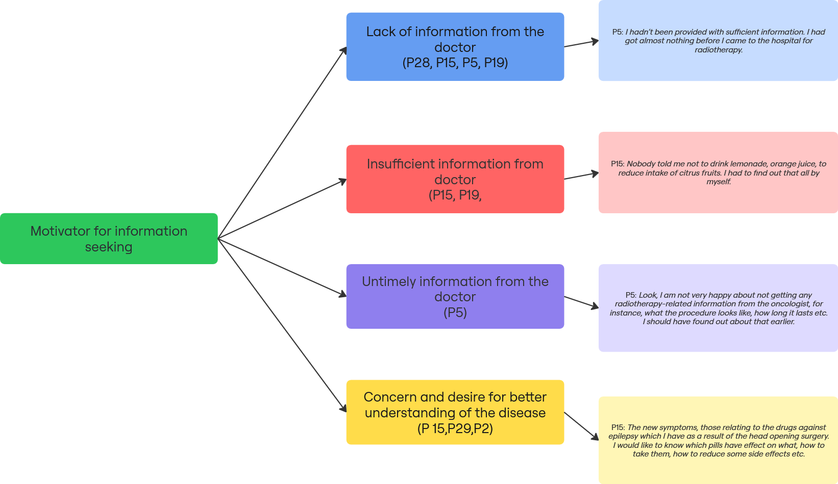

Figure 3. Motivators for information seeking among brain tumour patients
Legend: Colour-coded branches represent different motivators: blue for lack of information, red for insufficient information, purple for untimely information, and yellow for concern and desire for better understanding of the disease. Each branch is supported by a relevant participant quote.
Information seeking behavior of brain tumour patients
This study found that participants’ patterns to information varied in intensity, intention, and mode of engagement. As shown in Figure 4, three overarching orientations were identified: active information seeking, passive information seeking, and information avoidance. These categories were developed based on patterns observed in the data and are conceptually aligned with previous research on patient information behaviour (Costello & Veinot, 2020; Lambert et al., 2009a, 2009b). Patients who engaged in active information seeking described taking deliberate steps to acquire knowledge about their condition. Some reported engaging in intense information seeking, aiming to gather as much information as possible from various sources, including the internet, literature, and medical consultations. Others adopted a complementary approach, adding to the information received from healthcare professionals through their own efforts. Several participants described fortuitous information seeking, in which relevant insights were gained through informal conversations with fellow patients. Others demonstrated a verifying strategy, cross-checking information across multiple sources to ensure its reliability. Active seeking also included information via intermediaries, where participants involved others—typically family members or friends—in the search process. This ranged from proxy seeking, where the intermediary independently searched for information on behalf of the patient, to collaborative seeking, in which the patient and intermediary jointly engaged in information gathering. Participants who demonstrated passive information seeking engaged with health information in more limited or selective ways. Some described minimal involvement, relying solely on information provided by clinicians. Others adopted a guarded approach, purposefully avoiding specific types of information they perceived as emotionally difficult. Some individuals reported functioning primarily as receivers, encountering information in clinical settings without actively pursuing it. Others were identified as askers, who relied on posing occasional questions to healthcare professionals but did not engage in further information-seeking beyond these interactions. Information avoidance was also evident in the accounts of several participants. This orientation involved consciously distancing oneself from health-related information, often as a coping strategy to reduce anxiety, avoid distressing content, or maintain a sense of emotional control.
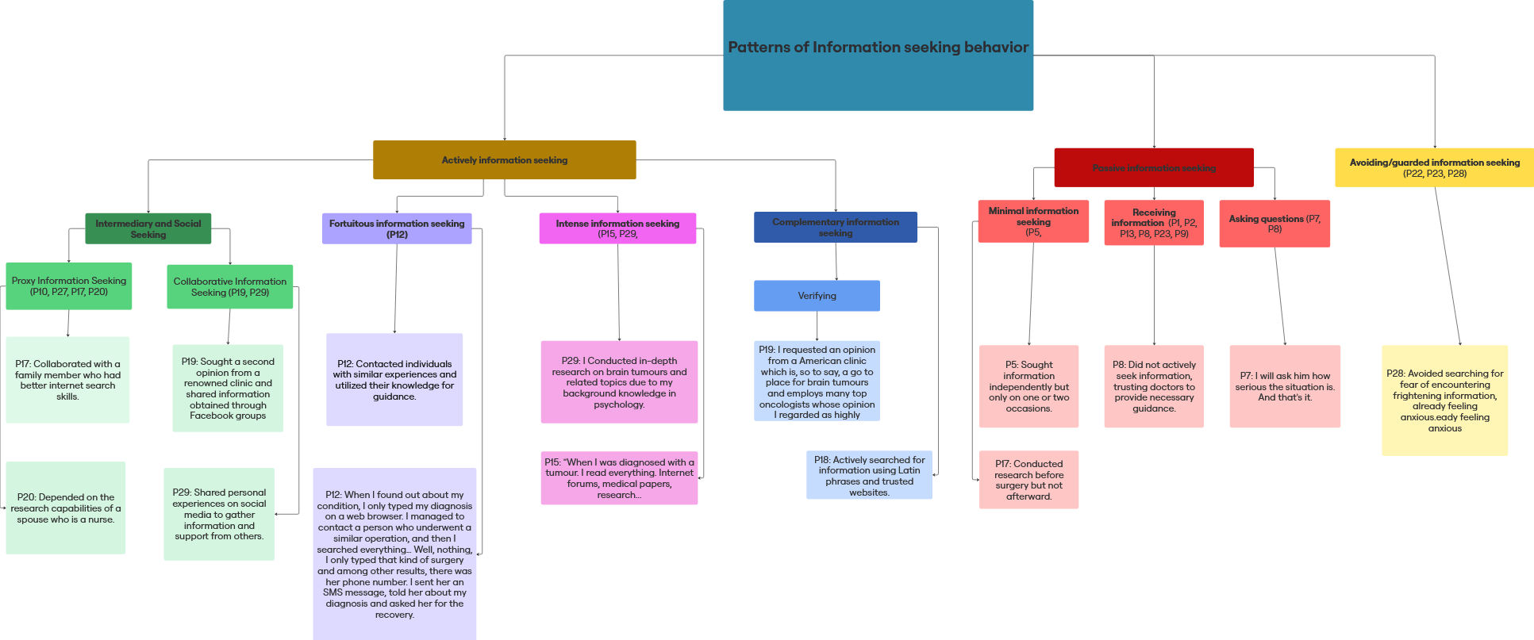

Figure 4. Patterns of information-seeking behaviour among brain tumour patients.
Legend: The diagram presents three overarching orientations—active, passive, and avoiding—each with associated subtypes. Active information seeking includes intense, complementary, fortuitous, verifiers, and information via intermediaries (comprising proxy and collaborative). Passive information seeking includes minimal, guarded, receivers, and askers. Avoidance represents a deliberate disengagement from cancer-related information.

Discussion

This study explored the health information needs, trust in information sources, motivators for information seeking, and patterns of information behaviour among brain tumour patients, some of whom were interviewed before surgery and others after surgery. Rather than tracking changes over time, the study focuses on understanding how patients in distinct stages of care engage with, seek, or avoid health information. The discussion is structured around the four research questions and interpreted in light of relevant theoretical and empirical literature.

RQ1: What information needs do patients with brain tumours have before and after surgery?
Patients in this study expressed a range of information needs, primarily related to understanding their diagnosis, the surgical procedure, postoperative recovery, and the competence of their physicians. These needs echo previous findings that highlight the critical role of accurate and timely information in reducing anxiety and enhancing patient autonomy (Doñate Marín et al., 2015; Chieffo et al., 2023). The desire for comprehensible explanations, particularly in the preoperative phase, supports Gautschi et al.'s (2010) observation that complex terminology and rushed consultations often exceed patients' cognitive capacity during emotionally charged moments. The results also align with Case's (2012) notion of information as instrumental to goal achievement and Ruthven's (2021) emphasis on the utility of information in performing health-related tasks. Participants consistently described information needs that served practical, emotional, and decision-making purposes. These needs were shaped by disease stage, treatment complexity, and emotional state, as previously reported by Chua et al. (2018) and Zhang et al. (2022). Importantly, the content and scope of information needs changed across the treatment trajectory. Before surgery, participants often expressed a desire to understand "everything"—from tumour types to possible risks and surgical details. After surgery, however, their questions became more specific, focusing on recovery, therapy, or new symptoms. For example, one participant who had asked broadly about tumour types and surgical risks preoperatively, later focused entirely on whether new symptoms were signs of relapse (P7). Another participant (P12) reported not seeking any information before surgery due to fear, but engaged in active information seeking afterward, once the operation had been successfully completed. Conversely, participant P3 actively sought detailed information before surgery but reported no further searching afterward, feeling that they had "already learned enough." These patterns reflect that information needs are dynamic and that the decision to seek or avoid information is influenced by changing emotional states, perceived urgency, and evolving informational goals. This variability supports prior literature indicating that information-seeking is shaped by personal characteristics such as personality traits, coping styles, gender, and education level (Looper et al., 2021; Miller, 1995; Rauthmann et al., 2015).

RQ2: What is the level of trust that patients with brain tumours place in different information sources?
The findings confirm that doctors, particularly neurosurgeons, are perceived as the most trustworthy sources of information, a view shaped by the perceived link between physician competence and surgical outcomes. This is consistent with prior studies (Madge et al., 2023; Chua et al., 2018) that emphasize the central role of doctors in the patient information ecosystem. Interestingly, while patients acknowledged the abundance of information online, many expressed ambivalence or distrust, especially regarding its reliability. This ambivalence aligns with research by Abdul-Mushin et al. (2017) and Madge et al. (2023), who found that although the internet has become a conventional source of health information, it is not universally trusted. Limited digital literacy or cognitive overload may inhibit autonomous information verification. Moreover, the absence of libraries or information professionals in participants' responses highlights a significant disconnect between the theoretical potential of health information professionals and their practical visibility in patient care. Although literature describes them as critical intermediaries in guiding patients toward reliable, understandable, and personalized health information (Seeger, 2015; Butler, 2019), their role remains largely unacknowledged by patients. This gap suggests a need for greater integration of information specialists into clinical teams and patient-facing services, particularly in contexts where cognitive and emotional burden limits patients’ ability to navigate complex information landscapes independently.

RQ3: What are the key motivators that lead brain tumour patients to seek information independently?

Consistent with models of uncertainty reduction (Taylor, 1968; Kuhlthau, 1993; Belkin, 2005), uncertainty emerged as a key driver of information seeking. The moment of diagnosis often catalysed a shift from latent to articulated information needs, aligning with Wilson and Walsh’s (1996) concept of problem recognition. Participants reported that they were better able to formulate questions or search terms after receiving a diagnosis, highlighting how diagnostic clarity initiates more active engagement with information systems. Consistent with Waitzkin (1991), the findings also point to temporal mismatches between the timing of patients’ information needs and the delivery of that information. Many described the information provided as delayed, insufficient, or overly generic, which frequently led to independent seeking. These results underscore the importance of timely, tailored, and iterative information provision, as emphasized by Madge et al. (2023).

RQ4: What patterns of information behaviour do brain tumour patients exhibit before and after surgery?
In line with Zimmerman and Shaw’s (2020) conceptualization of health information-seeking behaviour as a broad construct that includes diverse forms of interaction with information, findings from this study similarly reveal that participants engaged with information in ways that differed in depth, purpose, and approach. Participants exhibited diverse and overlapping patterns of information behaviour, including active seeking, passive engagement, and deliberate avoidance. These findings resonate with Brashers’ Uncertainty Management Theory (2001) and subsequent work (Brashers et al., 2002; Rains & Tukachinsky, 2015), which argue that seeking and avoidance are not opposites but complementary strategies for managing uncertainty and emotional distress. Importantly, there were observable differences in how patients approached information before and after surgery. The content and urgency of their information needs shifted: prior to surgery, patients often reported wanting to know "everything possible"—from basic definitions to worst-case scenarios—while after surgery, their questions became more targeted, often concerning recovery, side effects, or the meaning of new symptoms. For instance, participant P7 initially asked broad questions about tumour types and surgical outcomes, but postoperatively focused on interpreting headaches and dizziness as potential signs of recurrence. There was no consistent pattern indicating that those who did not seek information before surgery continued to avoid it afterwards. In fact, some participants (e.g., P12) began seeking information only after surgery, when their anxiety subsided or the need for specific knowledge emerged. Conversely, others (e.g., P3) who were highly engaged in the preoperative phase withdrew from further searching afterward, having met their perceived informational threshold. These dynamics suggest that information behaviour is fluid and shaped by personal coping styles, emotional readiness, and the changing demands of each illness phase. Although terms such as "proxy seeking" were used in this study to describe participants whose family members searched for information on their behalf, it is important to note that such terminology is interpretative rather than formally established in the literature. Nonetheless, this behavioural pattern reflects the importance of social networks in mediating patients’ access to information. Notably, information avoidance was not indicative of apathy but rather a self-protective response to emotional overload, as also observed by Barbour et al. (2012) and Hicks et al. (2024). This underscores the importance of recognizing that non-engagement with information may be intentional and contextually adaptive. The observed diversity in information behaviour reinforces the argument that health information practices are dynamic and contingent upon individual coping styles, digital skills, emotional readiness, and available support networks (Looper et al., 2021; Lloyd, 2006).

Conclusion
This study highlights the complexity and variability of information needs and behaviours among brain tumour patients in the pre- and postoperative phases, demonstrating how each phase presents distinct emotional and cognitive challenges that influence how patients seek, process, or avoid health-related information. Patients demonstrate a wide spectrum of engagement, ranging from proactive seeking to intentional avoidance. Their trust in doctors underscores the importance of clear and compassionate clinical communication, while their ambivalence toward digital sources reveals a need for guided access to trustworthy information. Equally important is the timely delivery of information—patients must receive relevant and comprehensible guidance at the moment when it is most needed. Delays in communication can intensify uncertainty, increase emotional distress, and hinder active participation in decision-making. Health information professionals can play a key role in bridging the gap between patient needs and the broader information ecosystem by becoming more visible, accessible, and embedded within both digital and clinical settings. Collaborations with healthcare providers, strategic involvement in online support communities, and the co-creation of targeted, evidence-based resources could significantly increase their perceived relevance and accessibility among patients. Given the consistently low awareness of their role observed in this study, information professionals must actively engage in outreach, patient education, and interprofessional advocacy to ensure that their expertise is recognized, valued, and structurally embedded in patient care pathways. While many patients desire to ask questions and seek clarification, barriers such as fear, stress, and perceived time constraints may inhibit such actions. Empowering patients therefore requires not only encouraging inquiry but also fostering communication environments that are safe, respectful, and responsive.
Limitations of this study include its focus on a single clinical setting in Croatia and a modest sample size, which may limit transferability. Additionally, retrospective accounts from postoperative participants may be affected by recall bias. For some participants, being interviewed preoperatively—on the day of surgery—may have influenced the length and complexity of their responses due to heightened anxiety and emotional strain. Future studies could explore how specific interventions by information professionals influence patient outcomes, particularly in terms of information comprehension, emotional well-being, and participation in shared decision-making. Further research is also needed to examine the impact of health literacy and how information behaviour shifts dynamically across diagnosis, treatment, recovery, and survivorship, and longitudinal studies would be particularly valuable given the evident variation in information needs across different stages of illness. Tracking patients over time could provide deeper insight into how informational preferences and behaviours evolve in response to changes in diagnosis, treatment, and emotional adjustment.

References

Abdul-Mushin, H., Raza, A., Chen, M., & Al-Jumaily, A. (2017). Understanding surgical patients’ information-seeking behaviour before and after procedures. Journal of Surgical Research, 212, 15–23.
Alamanou, D., Sapountzi-Krepia, D., & Tzavella, F. (2016). Surgical patients’ satisfaction related to preoperative and postoperative information. Health Science Journal, 10(2), 1–7.
Ancker, J. S., Witteman, H. O., Hafeez, B., Provencher, T., Van de Graaf, M., & Wei, E. (2015). The invisible work of personal health information management among people with multiple chronic conditions: Qualitative interview study among patients and providers. Journal of Medical Internet Research, 17(6), e137. https://doi.org/10.2196/jmir.4381
Barbour, J. B., Rintamaki, L. S., Ramsey, J. A., & Brashers, D. E. (2012). Avoiding health information. Journal of Health Communication, 17(3), 212–229.
Belkin, N. J. (2005). Anomalous states of knowledge as a basis for information retrieval. Canadian Journal of Information Science.
Bernstein, B. J., Grasso, M., & Wilkenfeld, R. (2011). Cancer patients’ information needs across the disease trajectory: A review of literature. Patient Education and Counseling, 82(3), 449–456.
Brashers, D. E. (2001). Communication and uncertainty management. Journal of Communication, 51(3), 477–497.
Brashers, D. E., Goldsmith, D. J., & Hsieh, E. (2002). Information seeking and avoiding in health contexts. Human Communication Research, 28(2), 258–271.
Butler, M. (2019). Empowering patients: Improving communication in complex care. American Journal of Hospice and Palliative Medicine, 36(9), 826–831. https://doi.org/10.1177/1049909119845634
Butler, M. (2019). The role of health information specialists in supporting patient-centred care. Journal of Consumer Health on the Internet, 23(3), 245–258.
Byström, K. (2002). Information and information sources in tasks of varying complexity. Journal of the American Society for Information Science and Technology, 53(7), 581–591.
Carlsson, M. E. (2000). Cancer patients seeking information from sources outside the health care system. Supportive Care in Cancer, 8(6), 453–457. https://doi.org/10.1007/s005200000190
Case, D. O. (2012). Looking for Information: A Survey of Research on Information Seeking, Needs and Behavior. 3rd ed.
Chang, H. L., Fung, K. Y., & Leung, A. W. Y. (2019). Information needs of cancer patients: A systematic review. Journal of Cancer Education, 34(1), 21–35.
Chieffo, D. P., et al. (2023). Preoperative education and its impact on surgical outcomes. Journal of Surgical Patient Care, 11(3), 205–210.
Chua, G. P., Tan, H. K., & Gandhi, M. (2018). Information needs and information seeking among cancer patients. European Journal of Oncology Nursing, 35, 37–46.
Costello, K. L., & Veinot, T. C. (2020). A spectrum of approaches to health information interaction: From avoidance to verification. Journal of Biomedical Informatics, 107, 103414. https://doi.org/10.1016/j.jbi.2020.103414
Council of Europe. (1997). Convention on Human Rights and Biomedicine (Oviedo Convention). Oviedo: Council of Europe.
Croatian Parliament. (2004). Patients’ Bill of Rights. Official Gazette of the Republic of Croatia, No. 169/2004.
Doñate Marín, M., Litago Cortés, M., Monge Sanz, Y., & Martínez Serrano, M. J. (2015). Information and anxiety in surgical patients. Journal of Advanced Nursing, 71(8), 1794–1802.
European Parliament and Council. (2011). Directive on patients’ rights in cross-border healthcare. Official Journal of the European Union, 2011/24/EU.
Faller, H., Koch, U., Brähler, E., Härter, M., Keller, M., Schulz, H., Wegscheider, K., Weis, J., & Mehnert, A. (2016). Online health information seeking among cancer patients. Psycho‐Oncology, 25(8), 875–882.
Fleisher, L. (2023). Effective communication in surgery. Annals of Surgery, 278(1), 2–5.
Frati, P. (2014). Role of health librarians in patient education. Health Information and Libraries Journal, 31(3), 181–185.
Gautschi, O. P., Stienen, M. N., Smoll, N. R., Corniola, M. V., Tessitore, E., & Schaller, K. (2010). Patient understanding of neurosurgical procedures. Acta Neurochirurgica, 152(12), 2001–2008.
Germeni, E., & Schulz, P. J. (2014). Information seeking and avoidance throughout the cancer patient journey: Two sides of the same coin? A qualitative comparison study. Patient Education and Counseling, 96(3), 326–332. https://doi.org/10.1016/j.pec.2014.01.002
Gille, S., Griese, L., & Schaeffer, D. (2021). Patient information and chronic disease management. Health Information Management Journal, 50(2), 70–79.
Gille, S., Griese, L., & Schaeffer, D. (2021). Preferences and Experiences of People with Chronic Illness in Using Different Sources of Health Information: Results of a Mixed-Methods Study. International journal of environmental research and public health, 18(24), 13185. https://doi.org/10.3390/ijerph182413185
HeMED, 2023. Hrvatska elektronička medicinska edukacija. MSD medicinski priručnik. = Croatian Electronic Medical Education. MSD Medical Manual.http://www.msd-prirucnici.placebo.hr/msd-za-pacijente/bolesti-mozga-i-zivcanog-sustava/tumori-zivcanog-sustava /tumori-mozga
Hicks, A., et al. (2024). Rethinking information avoidance. Information Processing & Management, 61(2), 103045.
Hrvatski zavod za javno zdravstvo (HZJZ). (2022). Izvješće o pojavnosti tumora u Hrvatskoj za 2022. godinu.
Jensen, J. G., Petersen, E., & Frandsen, T. F. (2021). Avoiding information during serious illness: Insights into the information behavior of cancer patients. Proceedings of the Association for Information Science and Technology, 58(1), 466–471.
Katavić Stanarević, S., Tanacković Faletar, S., & Badurina, B. (2016). Illness perception and information behavior of patients with rare chronic diseases. Information Research: An International Electronic Journal, 21(1). http://informationr.net/ir/21-1/paper704.html
Kuhlthau, C. C. (1993). A principle of uncertainty for information seeking. Journal of Documentation, 49(4), 339–355. https://doi.org/10.1108/eb026918
Kwanya, T. (2016). Digital information behavior. Global Knowledge, Memory and Communication, 65(4/5), 269–284. https://doi.org/10.1108/GKMC-11-2015-0086
Lambert, S. D., & Loiselle, C. G. (2007). Health information–seeking behavior. Qualitative Health Research, 17(8), 1006–1019.
Lambert, S. D., & Loiselle, C. G. (2007). Health information–seeking behavior. Qualitative Health Research, 17(8), 1006–1019. https://doi.org/10.1177/1049732307305199
Lambert, S. D., & Loiselle, C. G. (2009a). Exploring cancer information acquisition across the disease continuum: An application of the Cognitive–Social Health Information Processing model. Journal of Applied Social Psychology, 39(10), 2286–2307. https://doi.org/10.1111/j.1559-1816.2009.00523.x
Lambert, S. D., & Loiselle, C. G. (2009b). Health information—Seeking behavior. Qualitative Health Research, 19(8), 1006–1019. https://doi.org/10.1177/1049732309338956
Lloyd, A. (2006). Information literacy landscapes: An emerging picture. Journal of Documentation, 62(5), 570–583. https://doi.org/10.1177/0961000606066571
Loiselle, C. G. (2019). Navigating the maze of health information: Insights from monitoring–blunting coping styles. Healthcare Management Forum, 32(2), 65–68. https://doi.org/10.1177/0840470419835032
Looper, K. J., Capozzi, L. C., McDonald, M., Chasen, M., Fitch, M., & Fung, M. F. K. (2021). Patterns of online health information-seeking among cancer patients. Health Education & Behavior, 48(3), 376–385.
Madge, O. L., Marinca, A. M., Daha, C., & Simion, L. (2023). Health information seeking behaviour and decision making by patients undergoing breast cancer surgery: A qualitative study. Health Information and Libraries Journal. Advance online publication.
Malinen, S., Koivula, A., & Kimppa, K. K. (2018). The role of information in ethical consumer choice. Computers in Human Behavior, 86, 168–176. https://doi.org/10.1016/j.chb.2018.06.030
Miles, A., Voorwinden, S., Chapman, S., & Wardle, J. (2008). Psychologic predictors of cancer information avoidance among older adults: The role of cancer fear and fatalism. Personality and Individual Differences, 45(7), 768–772. https://doi.org/10.1016/j.paid.2008.06.005
Miller, S. M. (1995). Monitoring versus blunting styles of coping with cancer influence the information patients want and need about their disease. Cancer, 76(2), 167–177. https://doi.org/10.1002/1097-0142(19950715)76:2<167::AID-CNCR2820760203>3.0.CO;2-K
Mohamadali, N. A., et al. (2018). Information-seeking among cancer patients. Asian Pacific Journal of Cancer Prevention, 19(2), 399–405.
National Institute for Health and Care Excellence (NICE). (2020). Patient Information Guidelines. London: NICE.
Nelissen, S., Beullens, K., Lemal, M., Van den Bulck, J., & Van den Broeck, A. (2015). Fear of cancer and information avoidance: Examining the role of fear appeal messages and fear of cancer. Journal of Psychosomatic Research, 79(6), 580–585. https://doi.org/10.1016/j.jpsychores.2015.06.003
Nizet, P., Grivel, C., Rabeau, P., Pecout, S., Evin, A., Labarthe, S. P., Navas, D., Feuillet, F., Bourdon, M., & Huon, J. F. (2023). Patients' preferences in therapeutic decision-making in digestive oncology: a single centre cross-sectional observational study. Scientific reports, 13(1), 8534. https://doi.org/10.1038/
Persakis, E., & Kostagiolas, P. (2020). A framework for assessing the impact of information-seeking behavior on cancer patients' long-term prognosis. Advances in Experimental Medicine and Biology, 1196, 63–72. https://doi.org/10.1007/978-3-030-32633-1_6
Petersen, E., Jensen, J. G., & Frandsen, T. F. (2021). Information seeking for coping with cancer: A systematic review. Aslib Journal of Information Management, 73(6), 885-903.
Pizzarelli, G., Corradi, A., De Vito, C., Poscia, A., Ricciardi, W., & Federici, A. (2019). Improving patient engagement: The role of informational continuity and tailored educational programs in chronic care. Medical Decision Making, 39(4), 416–428. https://doi.org/10.1177/0272989X19826703
Rains, S. A., & Tukachinsky, R. (2014). An Examination of the Relationships Among Uncertainty, Appraisal, and Information-Seeking Behavior Proposed in Uncertainty Management Theory. Health Communication, 30(4), 339–349.
Rauthmann, J. F., Gallardo-Pujol, D., Guillaume, E. M., Todd, E., Nave, C. S., Sherman, R. A., Ziegler, M., Jones, A. B., & Funder, D. C. (2014). The Situational Eight DIAMONDS: A taxonomy of major dimensions of situation characteristics. Journal of Personality and Social Psychology, 107(4), 677–718.
Rauthmann, J. F., Sherman, R. A., Nave, C. S., & Funder, D. C. (2015). Personality-driven situation experience, contact, and construal: How people’s personality traits predict characteristics of their situations in daily life. Journal of Research in Personality, 55, 98–111.
Rolnick, S. J., Altschuler, A., Nekhlyudov, L., Elmore, J. G., Greene, S. M., Harris, E. L., Herrinton, L. J., Barton, M. B., Geiger, A. M., & Fletcher, S. W. (2007). What women wish they knew before prophylactic mastectomy. Cancer Nursing, 30(4), 285-293. https:/ /doi.org/10.1097/01.NCC.0000281733. 40856.c4
Ruthven, I. (2021). Resonance and the experience of relevance. Journal of the Association for In-formation Science and Technology, 72, 554–569. https://doi.org/10.1002/asi.24424
Saastamoinen, M., Järvelin, K., & Ingwersen, P. (2012). Task complexity affects information seeking and use. Information Processing & Management, 48(6), 1134–1149.
Salari, N., et al. (2023). Global epidemiology of brain tumours. Neuro-Oncology Advances, 5(1), vda085.
Schaeffer D., Haslbeck J. Bewältigung Chronischer Krankheit. In: Richter M., Hurrelmann K., editors. Soziologie von Gesundheit und Krankheit. Springer Fachmedien; Wiesbaden, Germany: 2016. pp. 243–256.
Schönbrodt, F. D., & Perugini, M. (2013). At what sample size do correlations stabilize? Journal of Research in Personality, 47(5), 609–612.
Seeger, M. W. (2015). Best practices in crisis communication: An expert panel process. Health Education & Behavior, 42(1_suppl), 122S–129S. https://doi.org/10.1177/1090198115579415
Shim, M., Kelly, B., & Hornik, R. (2016). Cancer information avoidance: Predicting avoidance behavior and the role of information overload in the avoidance process. Social Science & Medicine, 146, 204–210. https://doi.org/10.1016/j.socscimed.2016.02.032
Sorta-Bilajac, I. (2011). Patient autonomy and informed consent in Croatia. Croatian Medical Journal, 52(5), 567–574.
Sweeny, K., Melnyk, D., Miller, W., & Shepperd, J. A. (2010). Information avoidance: Who, what, when, and why. Review of General Psychology, 14(4), 340–353. https://doi.org/10.1037/a0018234
Taylor, R.S. (1968). Question-negotiation and information seeking in libraries. College & Research Libraries, 29(3), 178-194.
Tesfa, G. A., Demeke, A. D., Zewold, M., & Ngusie, H. S. (2024). Health information-seeking behavior among people living with the two common chronic diseases in low and middle-income countries (LMICs). A systematic review and meta-analysis. Digital health, 10, 20552076241302241. https://doi.org/10.1177/20552076241302241
van der Smissen, D., Rietjens, J. A. C., van Gemert-Pijnen, L., van Dulmen, S., van der Heide, A., & Korfage, I. J. (2021). Information needs of patients with chronic diseases and their relatives for web-based advance care planning: a qualitative interview study. BMC palliative care, 20(1), 77.
Waitzkin, H. (1991). The politics of medical encounters and how patients and doctors deal with social problems. New Haven, CT: Yale University Press.
Warren, S., et al. (2014). Impact of postoperative information on recovery. International Journal of Nursing Studies, 51(8), 1230–1239.
WHO. (1994). Declaration on the Promotion of Patients' Rights in Europe. Copenhagen: WHO Regional Office for Europe.
Wilson, T. D., & Walsh, C. (1996). Information behaviour: An interdisciplinary perspective (British Library Research and Innovation Report No. 10). University of Sheffield, Department of Information Studies. http://informationr.net/tdw/publ/infbehav/index.html
Wittmann, E., et al. (2010). Patients’ challenges accessing health information. Health Information & Libraries Journal, 27(2), 119–129.
Zhang, Y., Yi, S., Trace, C. B., & Williams-Brown, M. Y. (2022). Understanding the Information Needs of Patients With Ovarian Cancer Regarding Genetic Testing to Inform Intervention Design: Interview Study. JMIR cancer, 8(1), e31263. https://doi.org/10.2196/31263
Zimmerman, M. S., & Shaw, G. (2020). Health information seeking behavior: A concept analysis. Health Information & Libraries Journal, 37(3), 173–191. https://doi.org/10.1111/hir.12287

